1. **Create and Configure a User Named devops with Sudo Privileges**  
     
   # Update the package list

sudo apt-get update

# Create a new user named 'devops'

sudo adduser devops

# Add the user 'devops' to the 'sudo' group

sudo usermod -aG sudo devops  
  
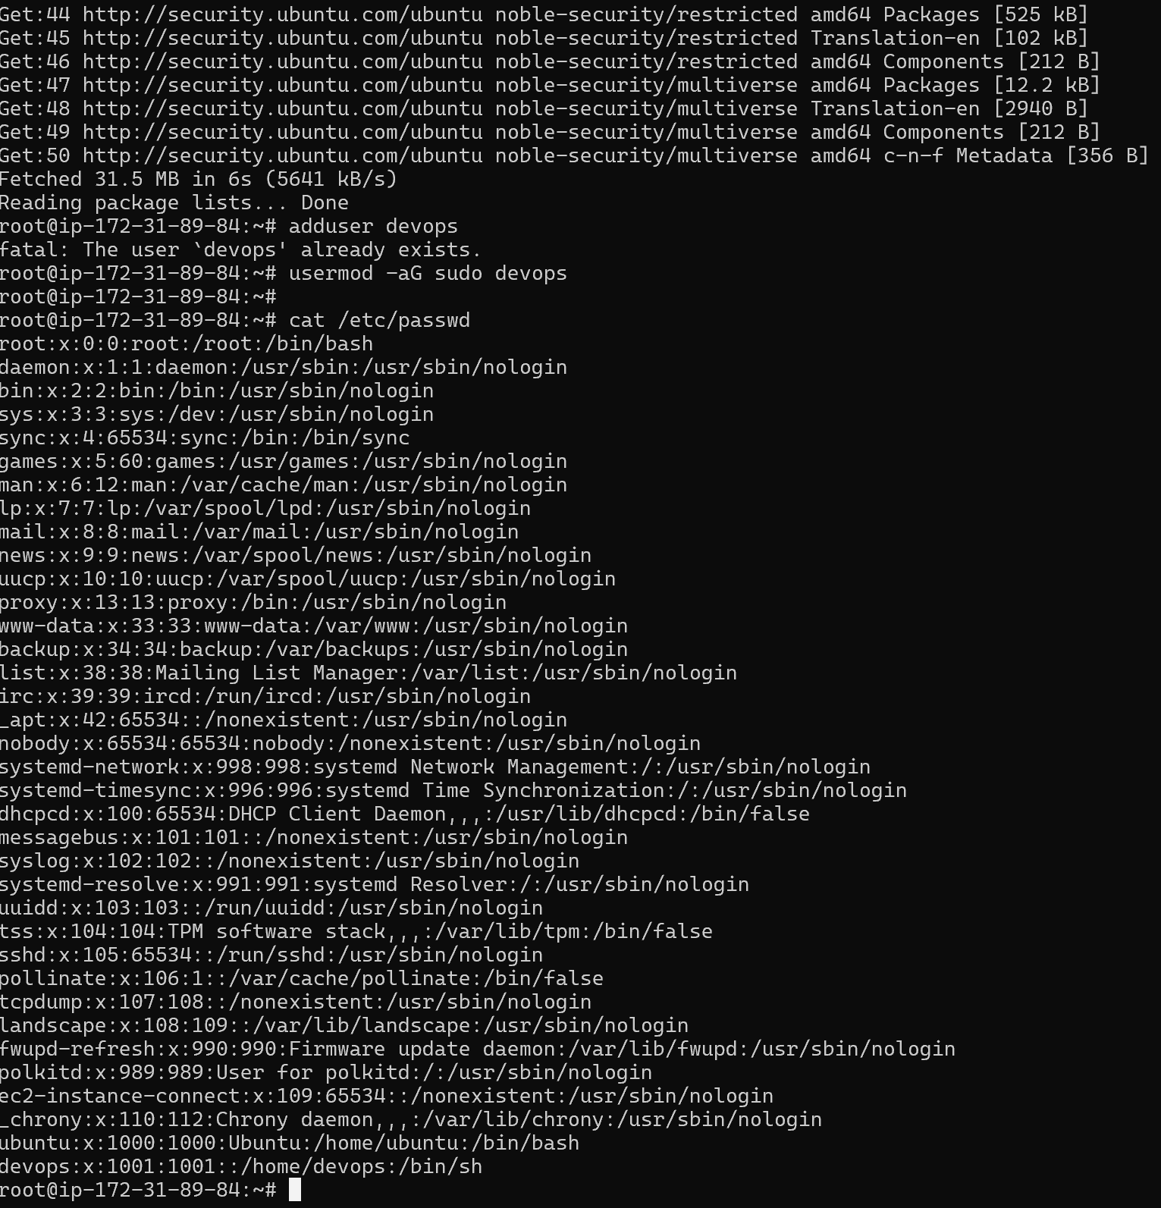

1. **Install Nginx**

#sudo apt-get install nginx

1. **Configure Nginx to Serve a Static HTML Page on Port 80**

#vim /var/www/html/index.html

1. Nginx Configuration File:  
   nano /etc/nginx/sites-available/default  
     
   server {

listen 80 default_server;

listen [::]:80 default_server;

root /var/www/html;

index index.html;

server_name _;

location / {

try_files $uri $uri/ =404;

}

}

systemctl restart nginx